**The Call Stack**

|  |  |
| --- | --- |
| **Case 1** | **Case 1** |
| **Main()**  **X =10**  **Print X**  **f1();**  **X = f2();**  **f3(X);**  **print X** |  |
|  |  |
| **Void f1()**  **Print “f1”**  **Return** |  |
|  |  |
| **Void f2()**  **Return 30** |  |
|  |  |
| **Void f3(X)**  **Print “f3”, X**  **X = X+10**  **Return** |  |

|  |  |
| --- | --- |
| **Case 2** |  |
| **Main()**  **X =10**  **Print X**  **f1();**  **print “over”** |  |
|  |  |
| **Void f1()**  **X=5**  **Print “f1”**  **F2();**  **Return** |  |
|  |  |
| **Void f2()**  **X=20**  **F3(X)**  **Return 30** |  |
|  |  |
| **Void f3(X)**  **Print “f3”, X**  **X = X+10**  **Return** |  |

**Demands for the Stack type storage structure to maintain call and return information…. Call Stack is a solution**

Stack data structure that stores information about the active subroutines of a computer program.

* A subroutine is a sequence of program instructions that perform a specific task, packaged as a unit and can be used in programs wherever the task should be performed.
* *Subroutine c can be a method or a function*.
* The main purpose of the Call Stack is to keep track of the point to which each active subroutine should return control when it finishes executing.
* Call Stack are usually hidden from the programmer.
  + They are given access only to a set of functions, and not the memory on the stack itself.
  + This is an example of abstraction.
  + Most assembly languages, on the other hand, require programmers to be involved with manipulating the stack.
* How does the Stack used for “Call and Return”
  + Since the Call Stack is organized as a stack, the caller pushes the return address onto the stack,
  + and the called subroutine, when it finishes, pulls or pops the return address off the Call Stack and transfers control to that address.
  + If a called subroutine calls on yet another subroutine, it will push another return address onto the Call Stack, and so on, with the information stacking up and unstacking as the program dictates.
  + The Call Stack only fix space in as the pushing consumes allocated space within the Call Stack, a stack overflow can occur causing the program to crash.

**Function call stack** in C.

The function call stack (often referred to just as the *call stack* or *the stack*) is responsible for maintaining the local variables and parameters during function execution.

Understanding how the call stack works explains how functions actually "work" including the following.

* The difference between function arguments and variables used to call functions
* Why several variables with the same name but residing in different function can co-exist
* Why there are certain limitations on what functions can do
* Why local variables that are not initialized might have any value contained in them.

### Assumptions

* ints are 4 bytes (32-bits) and doubles are 8 bytes (64-bits). This is the case on many modern platforms but may vary somewhat and is not guaranteed by the C standard.
* The starting address of the first stack frame is chosen arbitrarily. In most cases, it is not important where it starts, only to understand the mechanics of how it grows and shrinks.

### Suggestion

Open up the source code associated with this document in a different program or browser window. View the stack behavior in the browser and follow along in source code as steps are taken.

**Sample Code:**

C = A+B

Load A

Add B

STA C

C = mogrigy(A, B)

1 Call Mogrigy(A,B)

2 STA C

3 print “ “

4 input()

[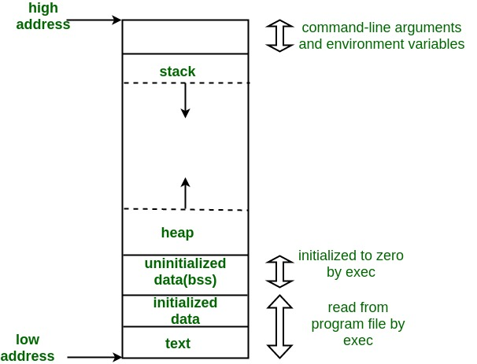](https://media.geeksforgeeks.org/wp-content/uploads/memoryLayoutC.jpg)

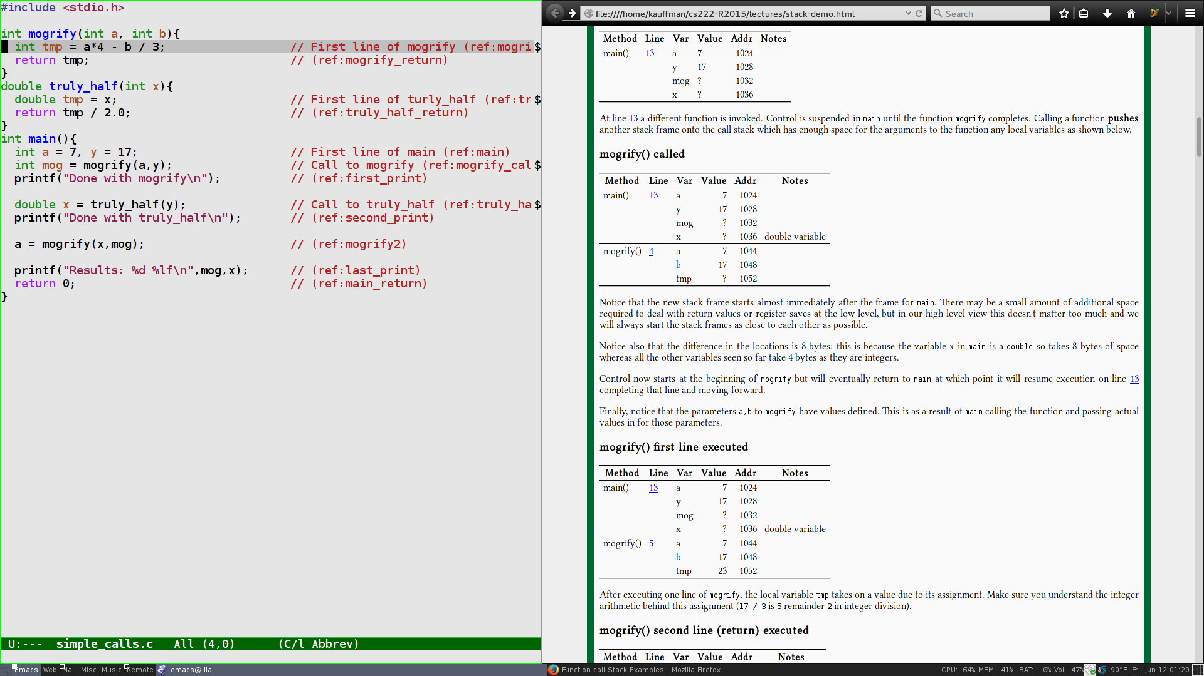

1: #include <stdio.h>

2:

3: int mogrify(int a, int b){

4: int tmp = a*4 - b / 3; // First line of mogrify (mogrify)

5: return tmp; // (mogrify_return)

6: }

7: double truly_half(int x){

8: double tmp = x / 2.0; // First line of turly_half (truly_half)

9: return tmp; // (truly_half_return)

10: }

11: int main(){

12: int a = 7, y = 17; // First line of main (main)

13: int mog =mogrify(a,y); // Call to mogrify (mogrify_call)

//13.a Call

//13.b mog = return val

14: printf("Done with mogrify\n"); // (first_print)

15:

16: double x = truly_half(y); // Call to truly_half (truly_half_call)

17: printf("Done with truly_half\n"); // (second_print)

18:

19: a = mogrify(x,mog); // (mogrify2)

20:

21: printf("Results: %d %lf\n",mog,x); // (last_print)

22: return 0; // (main_return)

23: }

### Call Stack behavior

Like all programs, control for the program starts in the main() function with the first line. main() has 3 local variables: a,y which are ints and x which is a double. The initial state of the stack is as follows.

### main() called

| **Method** | **Line** | **Var** | **Value** | **Addr** | **Notes** |
| --- | --- | --- | --- | --- | --- |
| main() | [12](https://cs.gmu.edu/~kauffman/cs222/stack-demo.html#coderef-main) | A | ? | 1024 |  |
|  |  | Y | ? | 1028 |  |
|  |  | Mog | ? | 1032 |  |
|  |  | X | ? | 1036 |  |

Notice that at the beginning of running main (line [12](https://cs.gmu.edu/~kauffman/cs222/stack-demo.html#coderef-main)),

* stack space is allocated for all of its local variables but none of them have defined values yet.
* C programs do not guarantee local variables are initialized to anything and it is a mistake to use a variable value without first ensuring it has a well-defined value.

After moving ahead one line in main, locals a,y have defined values.

* This probably constitutes several low-level machine/assembly instructions.

### One line of main() executed

| **Method** | **Line** | **Var** | **Value** | **Addr** | **Notes** |
| --- | --- | --- | --- | --- | --- |
| main() | [13](https://cs.gmu.edu/~kauffman/cs222/stack-demo.html#coderef-mogrify_call) | A | 7 | 1024 |  |
|  |  | Y | 17 | 1028 |  |
|  |  | Mog | ? | 1032 |  |
|  |  | X | ? | 1036 |  |

13: int mog = mogrify(a,y); // Call to mogrify (mogrify_call)

* At line [13](https://cs.gmu.edu/~kauffman/cs222/stack-demo.html#coderef-mogrify_call) a different function is invoked.
* Control is suspended in main until the function mogrify completes.
* Calling a function **pushes another stack frame** onto the call stack which has enough space for the arguments to the function any local variables as shown below.

### mogrify() called

| **Method** | **Line** | **Var** | **Value** | **Addr** | **Notes** |
| --- | --- | --- | --- | --- | --- |
| main() | [13](https://cs.gmu.edu/~kauffman/cs222/stack-demo.html#coderef-mogrify_call) | a | 7 | 1024 |  |
|  |  | y | 17 | 1028 |  |
|  |  | mog | ? | 1032 |  |
|  |  | x | ? | 1036 | double variable |
| mogrify() | [4](https://cs.gmu.edu/~kauffman/cs222/stack-demo.html#coderef-mogrify) | a | 7 | 1044 |  |
|  |  | b | 17 | 1048 |  |
|  |  | tmp | ? | 1052 |  |

Notice that the new stack frame starts almost immediately after the frame for main. There may be a small amount of additional space required to deal with return values or register saves at the low level, but in our high-level view this doesn't matter too much and we will always start the stack frames as close to each other as possible.

* Notice the allocation of  x in main is a double so takes 8 bytes of space
* Control now starts at the beginning of mogrify but will eventually return to main at which point it will resume execution on line [13](https://cs.gmu.edu/~kauffman/cs222/stack-demo.html#coderef-mogrify_call) completing that line and moving forward.
* Finally, notice that the parameters a,b to mogrify have values defined. This is as a result of main calling the function and passing actual values in for those parameters.
* The local variable tmp does not yet have known value associated with it as the first line of mogrify has not yet executed.

### mogrify() first line executed

| **Method** | **Line** | **Var** | **Value** | **Addr** | **Notes** |
| --- | --- | --- | --- | --- | --- |
| main() | [13](https://cs.gmu.edu/~kauffman/cs222/stack-demo.html#coderef-mogrify_call) | a | 7 | 1024 |  |
|  |  | y | 17 | 1028 |  |
|  |  | mog | ? | 1032 |  |
|  |  | x | ? | 1036 | double variable |
| mogrify() | [5](https://cs.gmu.edu/~kauffman/cs222/stack-demo.html#coderef-mogrify_return) | a | 7 | 1044 |  |
|  |  | b | 17 | 1048 |  |
|  |  | tmp | 23 | 1052 |  |

5: return tmp; // (mogrify_return)

### mogrify() second line (return) executed

| **Method** | **Line** | **Var** | **Value** | **Addr** | **Notes** |
| --- | --- | --- | --- | --- | --- |
| main() | [13](https://cs.gmu.edu/~kauffman/cs222/stack-demo.html#coderef-mogrify_call) | a | 7 | 1024 |  |
|  |  | y | 17 | 1028 |  |
|  |  | mog | 23 | 1032 |  |
|  |  | x | ? | 1036 | double variable |

* The second line of mogrify is to return a value to the calling function. This has two effects.
* The return value is stored wherever it was intended from the calling function: line [13](https://cs.gmu.edu/~kauffman/cs222/stack-demo.html#coderef-mogrify_call) of main stores the value in variable mog.
* Returning **pops the stack frame** for mogrify off the call stack leaving it in the state above.
* Control now resumes in main by advancing one line forward.

| **Method** | **Line** | **Var** | **Value** | **Addr** | **Notes** |
| --- | --- | --- | --- | --- | --- |
| main() | [14](https://cs.gmu.edu/~kauffman/cs222/stack-demo.html#coderef-first_print) | a | 7 | 1024 |  |
|  |  | y | 17 | 1028 |  |
|  |  | mog | 23 | 1032 |  |
|  |  | x | ? | 1036 | double variable |

### Executing a printf

| **Method** | **Line** | **Var** | **Value** | **Addr** | **Notes** |
| --- | --- | --- | --- | --- | --- |
| main() | [14](https://cs.gmu.edu/~kauffman/cs222/stack-demo.html#coderef-first_print) | a | 7 | 1024 |  |
|  |  | y | 17 | 1028 |  |
|  |  | mog | 23 | 1032 |  |
|  |  | x | ? | 1036 | double variable |
| printf() | library call | fmt | ?? | 1044 | 4-byte pointer |
|  |  | ?? | 7 | 1048 |  |

* printf is like other functions in that it will push another stack frame onto the stack with space for its arguments and local variables.
* printf is a little unique in that it is a *variadic* function:
  + it can take any number of arguments so long as the arguments coincide with the format string.
  + We shall skip description for execution of printf()

OutPut : Done with mogrify

and returns which pops its stack frame. Control resumes in main at the next relevant line of code.

11: int main(){

12: int a = 7, y = 17; // First line of main (main)

13: int mog = mogrify(a,y); // Call to mogrify (mogrify_call)

14: printf("Done with mogrify\n"); // (first_print)

15:

16: double x = truly_half(y); // Call to truly_half (truly_half_call)

17: printf("Done with truly_half\n"); // (second_print)

### Second function call

| **Method** | **Line** | **Var** | **Value** | **Addr** | **Notes** |
| --- | --- | --- | --- | --- | --- |
| main() | [16](https://cs.gmu.edu/~kauffman/cs222/stack-demo.html#coderef-truly_half_call) | a | 7 | 1024 |  |
|  |  | y | 17 | 1028 |  |
|  |  | mog | 23 | 1032 |  |
|  |  | x | ? | 1036 | double variable |

At line [16](https://cs.gmu.edu/~kauffman/cs222/stack-demo.html#coderef-truly_half_call), another function is called which pushes another stack frame onto the call stack.

7: double truly_half(int x){

8: double tmp = x / 2.0; // First line of turly_half (truly_half)

9: return tmp; // (truly_half_return)

10: }

### truly_half() called

| **Method** | **Line** | **Var** | **Value** | **Addr** | **Notes** |
| --- | --- | --- | --- | --- | --- |
| main() | [16](https://cs.gmu.edu/~kauffman/cs222/stack-demo.html#coderef-truly_half_call) | a | 7 | 1024 |  |
|  |  | y | 17 | 1028 |  |
|  |  | mog | 23 | 1032 |  |
|  |  | x | ? | 1036 | double variable |
| truly_half() | [8](https://cs.gmu.edu/~kauffman/cs222/stack-demo.html#coderef-truly_half) | x | 17 | 1044 |  |
|  |  | tmp | ? | 1048 | double variable |

* When truly_half is called, its stack frame is pushed on below main; notice that the memory addresses for its local variables are identical to previous function calls to mogrify and printf.

Space on the stack is re-used by subsequent function calls. This has implications for the values of variables that are not assigned values which we may discuss later.

The first line of truly_half assigns tmp as follows.

### truly_half() first line executed

| **Method** | **Line** | **Var** | **Value** | **Addr** | **Notes** |
| --- | --- | --- | --- | --- | --- |
| main() | [16](https://cs.gmu.edu/~kauffman/cs222/stack-demo.html#coderef-truly_half_call) | a | 7 | 1024 |  |
|  |  | y | 17 | 1028 |  |
|  |  | mog | 23 | 1032 |  |
|  |  | x | ? | 1036 | double variable |
| truly_half() | [9](https://cs.gmu.edu/~kauffman/cs222/stack-demo.html#coderef-truly_half_return) | x | 17 | 1044 |  |
|  |  | tmp | 8.5 | 1048 | double variable |

* Executing the next line of truly_half returns this value to assign the local variable x in main and pops the stack frame of truly_half off the call stack.

### Control returns to main

| **Method** | **Line** | **Var** | **Value** | **Addr** | **Notes** |
| --- | --- | --- | --- | --- | --- |
| main() | [17](https://cs.gmu.edu/~kauffman/cs222/stack-demo.html#coderef-second_print) | a | 7 | 1024 |  |
|  |  | y | 17 | 1028 |  |
|  |  | mog | 23 | 1032 |  |
|  |  | x | 8.5 | 1036 | double variable |

In main another result is printed

Done with truly_half

and control advances. Line [19](https://cs.gmu.edu/~kauffman/cs222/stack-demo.html#coderef-mogrify2) calls mogrify again with different argument

11: int main(){

12: int a = 7, y = 17; // First line of main (main)

13: int mog = mogrify(a,y); // Call to mogrify (mogrify_call)

14: printf("Done with mogrify\n"); // (first_print)

15:

16: double x = truly_half(y); // Call to truly_half (truly_half_call)

17: printf("Done with truly_half\n"); // (second_print)

18:

19: a = mogrify(x,mog); // (mogrify2)

20:

21: printf("Results: %d %lf\n",mog,x); // (last_print)

22: return 0; // (main_return)

23: }

3: int mogrify(int a, int b){

4: int tmp = a*4 - b / 3; // First line of mogrify (mogrify)

5: return tmp; // (mogrify_return)

6: }

mogrify called again

| **Method** | **Line** | **Var** | **Value** | **Addr** | **Notes** |
| --- | --- | --- | --- | --- | --- |
| main() | [19](https://cs.gmu.edu/~kauffman/cs222/stack-demo.html#coderef-mogrify2) | a | 7 | 1024 |  |
|  |  | y | 17 | 1028 |  |
|  |  | mog | 23 | 1032 |  |
|  |  | x | 8.5 | 1036 | double variable |
| mogrify() | [4](https://cs.gmu.edu/~kauffman/cs222/stack-demo.html#coderef-mogrify) | a | 8 | 1044 | caste to int |
|  |  | b | 23 | 1048 |  |
|  |  | tmp | ? | 1052 |  |

* Control in main is suspended at a different location than the first call to mogrify (line [19](https://cs.gmu.edu/~kauffman/cs222/stack-demo.html#coderef-mogrify2) this time) but control begins again in mogrify at its first line (line [4](https://cs.gmu.edu/~kauffman/cs222/stack-demo.html#coderef-mogrify)).
* Notice that the first argument to mogrify in this call is a little interesting:
  + it was passed as a double with value 8.5 (x=8.5) but appears as an int with value 8.
  + The compiler has automatically inserted low-level instructions to caste the 8-byte floating point value to a 4-byte integer value.
  + Most of the time this is nice convenience which saves programmers the trouble of writing such code but it can create subtle bugs if the programmer did not intend for such a conversion to happen.

### mogrify first line (tmp =….) executed again

| **Method** | **Line** | **Var** | **Value** | **Addr** | **Notes** |
| --- | --- | --- | --- | --- | --- |
| main() | [19](https://cs.gmu.edu/~kauffman/cs222/stack-demo.html#coderef-mogrify2) | a | 7 | 1024 |  |
|  |  | y | 17 | 1028 |  |
|  |  | mog | 23 | 1032 |  |
|  |  | x | 8.5 | 1036 | double variable |
| mogrify() | [5](https://cs.gmu.edu/~kauffman/cs222/stack-demo.html#coderef-mogrify_return) | a | 8 | 1044 | caste to int |
|  |  | b | 23 | 1048 |  |
|  |  | tmp | 25 | 1052 |  |

### mogrify second line (return) executed again

| **Method** | **Line** | **Var** | **Value** | **Addr** | **Notes** |
| --- | --- | --- | --- | --- | --- |
| main() | [19](https://cs.gmu.edu/~kauffman/cs222/stack-demo.html#coderef-mogrify2) | a | 25 | 1024 |  |
|  |  | y | 17 | 1028 |  |
|  |  | mog | 23 | 1032 |  |
|  |  | x | 8.5 | 1036 | double variable |

mogrify completes assigning its result to local variable a in main and popping its stack frame off.

11: int main(){

12: int a = 7, y = 17; // First line of main (main)

13: int mog = mogrify(a,y); // Call to mogrify (mogrify_call)

14: printf("Done with mogrify\n"); // (first_print)

15:

16: double x = truly_half(y); // Call to truly_half (truly_half_call)

17: printf("Done with truly_half\n"); // (second_print)

18:

19: a = mogrify(x,mog); // (mogrify2)

20:

21: printf("Results: %d %lf\n",mog,x); // (last_print)

22: return 0; // (main_return)

23: }

The program completes by printing the final results

Results: 23 8.500000

and returning 0. Two things to note here:

* main is also a function which returns meaning its stack frame will be popped off and control will be returned to the mysterious and powerful **C runtime system** which is responsible for setting up main to run in the first place.
* The integer return value from main is passed back to whatever entity ran the program in the first place.

### Example 2: Source Code

1: #include <stdio.h>

2:

3: double f1(double x){

4: return x+1.0; // (f1_1)

5: }

6:

7: double f2(double x){

8: double tmp = f1(x); // (f2_1)

9: double z = f1(x+1); // (f2_2)

10: return (z+ tmp) / 2; // (f2_3)

11: }

12:

13: double f3(double x, double y){

14: double z = f1(1); // (f3_1)

15: double tmp1 = x*z; // (f3_2)

16: double tmp2 = f2(y); // (f3_3)

17: return tmp1+tmp2; // (f3_4)

18: }

19:

20: int main(){

21: double x = 2; // (main_1)

22: double y = f3(x, x+3); // (main_2)

23: printf("%.3lf\n",y); // (main_3)

24: return 0; // (main_4)

25: }

### Call stack behavior

This is a somewhat more involved example. The computation doesn't do anything particularly interesting but is a good demonstration of how the stack can grow and shrink as one function calls another function. Little explanation is given in each step so pay careful attention to which line is being executed and remember that after a return is executed, control returns to the previous function and a stack frame is popped off.

Two minor notes

* All of the variables in this example are double so are assumed to be 8 bytes which means the size of memory cells will differ by 8
* The stack starts at memory address 2048 this time. In examples it is fairly arbitrary where the frame for main starts in the stack but after specifying its location, the behavior of the program follows a well-defined patter.

20: int main(){

21: double x = 2; // (main_1)

22: double y = f3(x, x+3); // (main_2)

23: printf("%.3lf\n",y); // (main_3)

24: return 0; // (main_4)

25: }

### main() called

| **Method** | **Line** | **Var** | **Value** | **Addr** | **Notes** |
| --- | --- | --- | --- | --- | --- |
| main() | [21](https://cs.gmu.edu/~kauffman/cs222/stack-demo.html#coderef-main_1) | x | ? | 2048 |  |
|  |  | y | ? | 2056 |  |

### main() line 1 finished

| **Method** | **Line** | **Var** | **Value** | **Addr** | **Notes** |
| --- | --- | --- | --- | --- | --- |
| main() | [22](https://cs.gmu.edu/~kauffman/cs222/stack-demo.html#coderef-main_2) | x | 2.0 | 2048 |  |
|  |  | y | ? | 2056 |  |

### f3 called

| **Method** | **Line** | **Var** | **Value** | **Addr** | **Notes** |
| --- | --- | --- | --- | --- | --- |
| main() | [22](https://cs.gmu.edu/~kauffman/cs222/stack-demo.html#coderef-main_2) | x | 2.0 | 2048 |  |
|  |  | y | ? | 2056 |  |
| f3() | [14](https://cs.gmu.edu/~kauffman/cs222/stack-demo.html#coderef-f3_1) | x | 2.0 | 2064 |  |
|  |  | y | 5.0 | 2072 |  |
|  |  | z | ? | 2080 |  |
|  |  | tmp1 | ? | 2088 |  |
|  |  | tmp2 | ? | 2096 |  |

13: double f3(double x, double y){

14: double z = f1(1); // (f3_1)

15: double tmp1 = x*z; // (f3_2)

16: double tmp2 = f2(y); // (f3_3)

17: return tmp1+tmp2; // (f3_4)

18: }

19:

### f3 calls f1 on line 1

| **Method** | **Line** | **Var** | **Value** | **Addr** | **Notes** |
| --- | --- | --- | --- | --- | --- |
| main() | [22](https://cs.gmu.edu/~kauffman/cs222/stack-demo.html#coderef-main_2) | x | 2.0 | 2048 |  |
|  |  | y | ? | 2056 |  |
| f3() | [14](https://cs.gmu.edu/~kauffman/cs222/stack-demo.html#coderef-f3_1) | x | 2.0 | 2064 |  |
|  |  | y | 5.0 | 2072 |  |
|  |  | z | ? | 2080 |  |
|  |  | tmp1 | ? | 2088 |  |
|  |  | tmp2 | ? | 2096 |  |
| f1 | [4](https://cs.gmu.edu/~kauffman/cs222/stack-demo.html#coderef-f1_1) | x | 1.0 | 2104 |  |

3: double f1(double x){

4: return x+1.0; // (f1_1)

5: }

13: double f3(double x, double y){

14: double z = f1(1); // (f3_1)

15: double tmp1 = x*z; // (f3_2)

16: double tmp2 = f2(y); // (f3_3)

17: return tmp1+tmp2; // (f3_4)

18: }

### f1 returns, stack frame popped, f3 advances to next line

| **Method** | **Line** | **Var** | **Value** | **Addr** | **Notes** |
| --- | --- | --- | --- | --- | --- |
| main() | [22](https://cs.gmu.edu/~kauffman/cs222/stack-demo.html#coderef-main_2) | x | 2.0 | 2048 |  |
|  |  | y | ? | 2056 |  |
| f3() | [15](https://cs.gmu.edu/~kauffman/cs222/stack-demo.html#coderef-f3_2) | x | 2.0 | 2064 |  |
|  |  | y | 5.0 | 2072 |  |
|  |  | z | 2.0 | 2080 |  |
|  |  | tmp1 | ? | 2088 |  |
|  |  | tmp2 | ? | 2096 |  |

### f3 executes second line

| **Method** | **Line** | **Var** | **Value** | **Addr** | **Notes** |
| --- | --- | --- | --- | --- | --- |
| main() | [22](https://cs.gmu.edu/~kauffman/cs222/stack-demo.html#coderef-main_2) | x | 2.0 | 2048 |  |
|  |  | y | ? | 2056 |  |
| f3() | [16](https://cs.gmu.edu/~kauffman/cs222/stack-demo.html#coderef-f3_3) | x | 2.0 | 2064 |  |
|  |  | y | 5.0 | 2072 |  |
|  |  | z | 2.0 | 2080 |  |
|  |  | tmp1 | 4.0 | 2088 |  |
|  |  | tmp2 | ? | 2096 |  |

3: double f1(double x){

4: return x+1.0; // (f1_1)

5: }

6:

7: double f2(double x){

8: double tmp = f1(x); // (f2_1)

9: double z = f1(x+1); // (f2_2)

10: return (z+ tmp) / 2; // (f2_3)

11: }

12:

13: double f3(double x, double y){

14: double z = f1(1); // (f3_1)

15: double tmp1 = x*z; // (f3_2)

16: double tmp2 = f2(y); // (f3_3)

17: return tmp1+tmp2; // (f3_4)

18: }

### f3 calls f2 on third line

| **Method** | **Line** | **Var** | **Value** | **Addr** | **Notes** |
| --- | --- | --- | --- | --- | --- |
| main() | [22](https://cs.gmu.edu/~kauffman/cs222/stack-demo.html#coderef-main_2) | x | 2.0 | 2048 |  |
|  |  | y | ? | 2056 |  |
| f3() | [16](https://cs.gmu.edu/~kauffman/cs222/stack-demo.html#coderef-f3_3) | x | 2.0 | 2064 |  |
|  |  | y | 5.0 | 2072 |  |
|  |  | z | 2.0 | 2080 |  |
|  |  | tmp1 | 4.0 | 2088 |  |
|  |  | tmp2 | ? | 2096 |  |
| f2() | [8](https://cs.gmu.edu/~kauffman/cs222/stack-demo.html#coderef-f2_1) | x | 5.0 | 2104 |  |
|  |  | tmp | ? | 2112 |  |
|  |  | z | ? | 2120 |  |

3: double f1(double x){

4: return x+1.0; // (f1_1)

5: }

6:

7: double f2(double x){

8: double tmp = f1(x); // (f2_1)

9: double z = f1(x+1); // (f2_2)

10: return (z+ tmp) / 2; // (f2_3)

11: }

12:

### f2 calls f1 on first line

| **Method** | **Line** | **Var** | **Value** | **Addr** | **Notes** |
| --- | --- | --- | --- | --- | --- |
| main() | [22](https://cs.gmu.edu/~kauffman/cs222/stack-demo.html#coderef-main_2) | x | 2.0 | 2048 |  |
|  |  | y | ? | 2056 |  |
| f3() | [16](https://cs.gmu.edu/~kauffman/cs222/stack-demo.html#coderef-f3_3) | x | 2.0 | 2064 |  |
|  |  | y | 5.0 | 2072 |  |
|  |  | z | 2.0 | 2080 |  |
|  |  | tmp1 | 4.0 | 2088 |  |
|  |  | tmp2 | ? | 2096 |  |
| f2() | [8](https://cs.gmu.edu/~kauffman/cs222/stack-demo.html#coderef-f2_1) | x | 5.0 | 2104 |  |
|  |  | tmp | ? | 2112 |  |
|  |  | z | ? | 2120 |  |
| f1() | [4](https://cs.gmu.edu/~kauffman/cs222/stack-demo.html#coderef-f1_1) | x | 5.0 | 2128 |  |

### f1 returns to f2, f2 advances to next line

| **Method** | **Line** | **Var** | **Value** | **Addr** | **Notes** |
| --- | --- | --- | --- | --- | --- |
| main() | [22](https://cs.gmu.edu/~kauffman/cs222/stack-demo.html#coderef-main_2) | x | 2.0 | 2048 |  |
|  |  | y | ? | 2056 |  |
| f3() | [16](https://cs.gmu.edu/~kauffman/cs222/stack-demo.html#coderef-f3_3) | x | 2.0 | 2064 |  |
|  |  | y | 5.0 | 2072 |  |
|  |  | z | 2.0 | 2080 |  |
|  |  | tmp1 | 4.0 | 2088 |  |
|  |  | tmp2 | ? | 2096 |  |
| f2() | [9](https://cs.gmu.edu/~kauffman/cs222/stack-demo.html#coderef-f2_2) | x | 5.0 | 2104 |  |
|  |  | tmp | 6.0 | 2112 |  |
|  |  | z | ? | 2120 |  |

3: double f1(double x){

4: return x+1.0; // (f1_1)

5: }

6:

7: double f2(double x){

8: double tmp = f1(x); // (f2_1)

9: double z = f1(x+1); // (f2_2)

10: return (z+ tmp) / 2; // (f2_3)

11: }

12:

### f2 calls f1 on second line

| **Method** | **Line** | **Var** | **Value** | **Addr** | **Notes** |
| --- | --- | --- | --- | --- | --- |
| main() | [22](https://cs.gmu.edu/~kauffman/cs222/stack-demo.html#coderef-main_2) | x | 2.0 | 2048 |  |
|  |  | y | ? | 2056 |  |
| f3() | [16](https://cs.gmu.edu/~kauffman/cs222/stack-demo.html#coderef-f3_3) | x | 2.0 | 2064 |  |
|  |  | y | 5.0 | 2072 |  |
|  |  | z | 2.0 | 2080 |  |
|  |  | tmp1 | 4.0 | 2088 |  |
|  |  | tmp2 | ? | 2096 |  |
| f2() | [9](https://cs.gmu.edu/~kauffman/cs222/stack-demo.html#coderef-f2_2) | x | 5.0 | 2104 |  |
|  |  | tmp | 6.0 | 2112 |  |
|  |  | z | ? | 2120 |  |
| f1() | [4](https://cs.gmu.edu/~kauffman/cs222/stack-demo.html#coderef-f1_1) | x | 6.0 | 2128 |  |

### f1 returns to f2, f2 advances to next line

| **Method** | **Line** | **Var** | **Value** | **Addr** | **Notes** |
| --- | --- | --- | --- | --- | --- |
| main() | [22](https://cs.gmu.edu/~kauffman/cs222/stack-demo.html#coderef-main_2) | x | 2.0 | 2048 |  |
|  |  | y | ? | 2056 |  |
| f3() | [16](https://cs.gmu.edu/~kauffman/cs222/stack-demo.html#coderef-f3_3) | x | 2.0 | 2064 |  |
|  |  | y | 5.0 | 2072 |  |
|  |  | z | 2.0 | 2080 |  |
|  |  | tmp1 | 4.0 | 2088 |  |
|  |  | tmp2 | ? | 2096 |  |
| f2() | [10](https://cs.gmu.edu/~kauffman/cs222/stack-demo.html#coderef-f2_3) | x | 5.0 | 2104 |  |
|  |  | tmp | 6.0 | 2112 |  |
|  |  | z | 7.0 | 2120 |  |

### f2 returns control to f3, f3 advances to next line

| **Method** | **Line** | **Var** | **Value** | **Addr** | **Notes** |
| --- | --- | --- | --- | --- | --- |
| main() | [22](https://cs.gmu.edu/~kauffman/cs222/stack-demo.html#coderef-main_2) | x | 2.0 | 2048 |  |
|  |  | y | ? | 2056 |  |
| f3() | [17](https://cs.gmu.edu/~kauffman/cs222/stack-demo.html#coderef-f3_4) | x | 2.0 | 2064 |  |
|  |  | y | 5.0 | 2072 |  |
|  |  | z | 2.0 | 2080 |  |
|  |  | tmp1 | 4.0 | 2088 |  |
|  |  | tmp2 | 6.5 | 2096 |  |

### f3 returns control to main, main advances to next

| **Method** | **Line** | **Var** | **Value** | **Addr** | **Notes** |
| --- | --- | --- | --- | --- | --- |
| main() | [23](https://cs.gmu.edu/~kauffman/cs222/stack-demo.html#coderef-main_3) | x | 2.0 | 2048 |  |
|  |  | y | 10.5 | 2056 |  |

### main calls printf on line 3

| **Method** | **Line** | **Var** | **Value** | **Addr** | **Notes** |
| --- | --- | --- | --- | --- | --- |
| main() | [23](https://cs.gmu.edu/~kauffman/cs222/stack-demo.html#coderef-main_3) | X | 2.0 | 2048 |  |
|  |  | Y | 10.5 | 2056 |  |
| printf() | library call | fmt | ? | 2064 | 4-byte pointer |
|  |  | ? | 10.5 | 2068 |  |

Output

10.500

### printf returns, main advances to next line

| **Method** | **Line** | **Var** | **Value** | **Addr** | **Notes** |
| --- | --- | --- | --- | --- | --- |
| main() | [24](https://cs.gmu.edu/~kauffman/cs222/stack-demo.html#coderef-main_4) | x | 2.0 | 2048 |  |
|  |  | y | 10.5 | 2056 |  |

### main returns 0, program ends

### Example 3: Source Code

1: /* Demonstration of call-by value and call stack */

2: #include <stdio.h>

3: void swap_ints(int *a, int *b){

4: int tmp = *a; // (swap_ints_1)

5: a = b; // (swap_ints_2)

6: b = tmp; // (swap_ints_3)

7: return; // (swap_ints_4)

8: }

9: int main(){

10: int x=20, y=50; // (main_1)

11: printf("x=%d y=%d\n",x,y); // (main_2)

12:

13: swap_ints(&x,&y); // (main_3)

14: /* What gets printed here? */

15: printf("x=%d y=%d\n",x,y); // (main_4)

16: return 0; // (main_5)

17: }

### Call stack behavior

It is common to want to swap the values of two variables. Unfortunately, writing a function to carry out this task in the most obvious way proves fruitless. One can understand why the swap_ints() function above does not actually swap values using the call stack. C allocates new memory for the arguments to functions and the actual argument values are copied into this area. Thus arguments within the function are distinct from any variables that were used to call the function. Changes to function parameters do not affect any other variables.

### main() called

As usual, execution starts in the main function.

| **Method** | **Line** | **Var** | **Value** | **Addr** | **Notes** |
| --- | --- | --- | --- | --- | --- |
| main() | [21](https://cs.gmu.edu/~kauffman/cs222/stack-demo.html#coderef-main_1) | X | ? | 2048 |  |
|  |  | Y | ? | 2052 |  |

### main() executes first line

| **Method** | **Line** | **Var** | **Value** | **Addr** | **Notes** |
| --- | --- | --- | --- | --- | --- |
| main() | [22](https://cs.gmu.edu/~kauffman/cs222/stack-demo.html#coderef-main_2) | X | 20 | 2048 |  |
|  |  | Y | 50 | 2052 |  |

### main calls printf

| **Method** | **Line** | **Var** | **Value** | **Addr** | **Notes** |
| --- | --- | --- | --- | --- | --- |
| main() | [22](https://cs.gmu.edu/~kauffman/cs222/stack-demo.html#coderef-main_2) | X | 20 | 2048 |  |
|  |  | Y | 50 | 2052 |  |
| printf() | library call | fmt | ? | 2056 | 4-byte pointer |
|  |  | ? | 20 | 2060 |  |
|  |  | ? | 50 | 2064 |  |

Output

x=20 y=50

### printf returns, main advances one line

| **Method** | **Line** | **Var** | **Value** | **Addr** | **Notes** |
| --- | --- | --- | --- | --- | --- |
| main() | [23](https://cs.gmu.edu/~kauffman/cs222/stack-demo.html#coderef-main_3) | X | 20 | 2048 |  |
|  |  | Y | 50 | 2052 |  |

### main calls swap_ints

| **Method** | **Line** | **Var** | **Value** | **Addr** | **Notes** |
| --- | --- | --- | --- | --- | --- |
| main() | [23](https://cs.gmu.edu/~kauffman/cs222/stack-demo.html#coderef-main_3) | X | 20 | 2048 |  |
|  |  | Y | 50 | 2052 |  |
| swapints() | [4](https://cs.gmu.edu/~kauffman/cs222/stack-demo.html#coderef-swap_ints_1) | A | 20 | 2056 |  |
|  |  | B | 50 | 2060 |  |
|  |  | tmp | ? | 2064 |  |

### swap_ints executes first line

| **Method** | **Line** | **Var** | **Value** | **Addr** | **Notes** |
| --- | --- | --- | --- | --- | --- |
| main() | [23](https://cs.gmu.edu/~kauffman/cs222/stack-demo.html#coderef-main_3) | X | 20 | 2048 |  |
|  |  | Y | 50 | 2052 |  |
| swapints() | [5](https://cs.gmu.edu/~kauffman/cs222/stack-demo.html#coderef-swap_ints_2) | A | 20 | 2056 |  |
|  |  | B | 50 | 2060 |  |
|  |  | tmp | 20 | 2064 |  |

### swap_ints executes second line

| **Method** | **Line** | **Var** | **Value** | **Addr** | **Notes** |
| --- | --- | --- | --- | --- | --- |
| main() | [23](https://cs.gmu.edu/~kauffman/cs222/stack-demo.html#coderef-main_3) | X | 20 | 2048 |  |
|  |  | Y | 50 | 2052 |  |
| swapints() | [6](https://cs.gmu.edu/~kauffman/cs222/stack-demo.html#coderef-swap_ints_3) | A | 50 | 2056 |  |
|  |  | B | 50 | 2060 |  |
|  |  | tmp | 20 | 2064 |  |

### swap_ints executes third line

| **Method** | **Line** | **Var** | **Value** | **Addr** | **Notes** |
| --- | --- | --- | --- | --- | --- |
| main() | [23](https://cs.gmu.edu/~kauffman/cs222/stack-demo.html#coderef-main_3) | X | 20 | 2048 |  |
|  |  | Y | 50 | 2052 |  |
| swapints() | [7](https://cs.gmu.edu/~kauffman/cs222/stack-demo.html#coderef-swap_ints_4) | A | 50 | 2056 |  |
|  |  | B | 20 | 2060 |  |
|  |  | tmp | 20 | 2064 |  |

### swap_ints returns

| **Method** | **Line** | **Var** | **Value** | **Addr** | **Notes** |
| --- | --- | --- | --- | --- | --- |
| main() | [23](https://cs.gmu.edu/~kauffman/cs222/stack-demo.html#coderef-main_3) | X | 20 | 2048 |  |
|  |  | Y | 50 | 2052 |  |

Note that the return type of swap_ints is void: it is not meant to return anything, only have side-effects by altering something about the program. This makes line [7](https://cs.gmu.edu/~kauffman/cs222/stack-demo.html#coderef-swap_ints_4)

return;

perfectly valid. Unfortunately, the desired side-effect of swapping the variables x,y in main has not been achieved. On advancing to the next line and printing, the output clearly shows that x,y have retained their original values.

x=20 y=50

This is because during the execution of swap_ints, the function had its own copies of the values 20,50 which referred to with names a,b. These are distinct from the x,y in main and change independently. This the swapping done in swap_ints does not affect any values in main.

### Real Swap Functions

It is not possible to use a simple function definition to get variable swapping to work. This is due to the call-by-value semantics C uses for function invocation. Instead, one must resort to more complex means to get swapping to work. Two common options are employed: (1) use a preprocessor macro, or (2) use pointers and addresses.

#### (1) Use a Preprocessor macro

The C preprocessor can be used to perform textural transformations on a program which is useful for swap-like operations. This is discussed in detail on [stack overflow](http://stackoverflow.com/questions/3982348/implement-generic-swap-macro-in-c). For a simple integer swapping, the following SWAP macro will work.

1: /* Demonstration of call-by value and call stack */

2: #include <stdio.h>

3:

4: #define SWAP(a,b) {int tmp=a; a=b; b=temp;}

5:

6: int main(){

7: int x=20, y=50;

8: printf("x=%d y=%d\n",x,y);

9:

10: SWAP(x,y);

11:

12: printf("x=%d y=%d\n",x,y);

13: return 0;

14: }

Note that the #define create what appears to be a function but it is really a textural transformation. After running the preprocessor, the program will be transformed to the following.

1: int main(){

2: int x=20, y=50;

3: printf("x=%d y=%d\n",x,y);

4:

5: {int tmp=x; x=y; y=x;}; // (macro_expansion)

6:

7: printf("x=%d y=%d\n",x,y);

8: return 0;

9: }

The preprocessor has substituted the definition of SWAP(a,b) with the macro expansion at line [5](https://cs.gmu.edu/~kauffman/cs222/stack-demo.html#coderef-macro_expansion).

#### (2) Use Pointers and Addresses

Pointer manipulations allow a swap function to be defined. We will revisit swapping when we discuss pointers.

**Terminology of Function Call Stack**

An area of program memory that is used to manage function calls. Program memory can be roughly divided into 4 parts:

* the function call stack which supports functions
* the heap (or store) which supports dynamic memory allocation,
* the global variable area which stores values for global variables
* the code area which stores the actual instructions for the running program which are usually not changed during execution

**stack frame**

A portion of memory in the function call stack associated with a single running function. Functions that have many parameters and local variables will have larger stack frames than those with few parameters and local variables. The compiler is able to determine during compilation the stack frame size for a function. There are usually as many stack frames on the stack as there are functions that have yet to return.

**pushing a frame**

When a function is called, a new frame is pushed onto the "top" of the function call stack. The frame will be big enough to hold all of the parameters to the function being called plus the space required for all local variables in a function.

**popping a frame**

When a function finishes executing, it returns control to the function it which called/invoked it. The frame associated with the returning function is removed from the top of the stack.

**active function / frame**

In serial programs (non-parallel programs), there is only one active function at any given moment in the program. This function is usually the one at the "top" of the function call stack and the active frame refers to the frame at the top of the call stack. Pushing and popping happen only at the top of the stack and change the active frame.

**stack overflow**

Memory is a finite resource and if too many functions are called before any returns, a program can run out of space on the stack. This usually happens only in the case of recursive functions that are misbehaving but for programs with very tight memory constraints it may happen in some kinds of programs.

*Author: Chris Kauffman (*[*kauffman@cs.gmu.edu*](mailto:kauffman@cs.gmu.edu)*)  
Date: 2015-06-17 Wed 16:26*

**Recursion**

Some computer programming languages allow a module or function to call itself. This technique is known as recursion. In recursion, a function **α** either calls itself directly or calls a function **β** that in turn calls the original function **α**. The function **α** is called recursive function.

**Example** − a function calling itself.

int function(int value) {

if(value > max)

return;

function(value + 1);

printf("%d ",value);

}

**Example** − a function that calls another function which in turn calls it again.

int function1(int value1) {

if(value1 < 1)

return;

function2(value1 - 1);

printf("%d ",value1);

}

int function2(int value2) {

function1(value2);

}

**Properties**

A recursive function can go infinite like a loop. To avoid infinite running of recursive function, there are two properties that a recursive function must have −

* **Base criteria** − There must be at least one base criteria or condition, such that, when this condition is met the function stops calling itself recursively.
* **Progressive approach** − The recursive calls should progress in such a way that each time a recursive call is made it comes closer to the base criteria.

**Implementation**

Many programming languages implement recursion by means of **stacks**. Generally, whenever a function (**caller**) calls another function (**callee**) or itself as callee, the caller function transfers execution control to the callee. This transfer process may also involve some data to be passed from the caller to the callee.

This implies, the caller function has to suspend its execution temporarily and resume later when the execution control returns from the callee function. Here, the caller function needs to start exactly from the point of execution where it puts itself on hold. It also needs the exact same data values it was working on. For this purpose, an activation record (or stack frame) is created for the caller function.

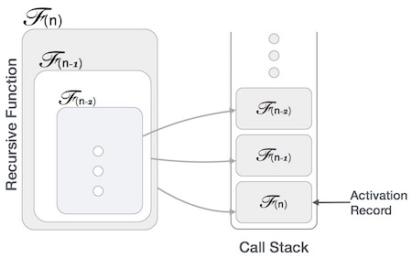

This activation record keeps the information about local variables, formal parameters, return address and all information passed to the caller function.

Analysis of Recursion

One may argue why to use recursion, as the same task can be done with iteration.

The first reason is, recursion makes a program more readable and because of latest enhanced CPU systems, recursion is more efficient than iterations.

Time Complexity

* In case of iterations, we take number of **iterations to count the time complexity**.
* Likewise, in case of recursion, assuming everything is constant, we try to figure out the number of times a recursive call is being made.
* A call made to a function is Ο(1), hence the (n) number of times a recursive call is made makes the recursive function Ο(n).

Space Complexity

* Space complexity is counted as what amount of extra space is required for a module to execute.
* In case of iterations, the compiler hardly requires any extra space. The compiler keeps updating the values of variables used in the iterations.
* But in case of recursion, the system needs to store activation record each time a recursive call is made.
* Hence, it is considered that space complexity of recursive function may go higher than that of a function with iteration.

1. Factorial of N

fact(n)

1. if(n==1 || n==0)……[can **write n<=1 also….check for base case]**

rc=1; //if n is 1 or 0 rc is 1

else{ //else it is recursive case

rc=n * fact(n-1); //rc is n * (n-1)!

2. return rc;

}

main()

1 aa = fact(4);

2. Print aa

When the program starts this is our run time stack:

https://cathyatseneca.gitbooks.io/data-structures-and-algorithms/content/assets/recursion1.png

fact(4) means that we call function fact() with 4 as argument so push that information onto the stack

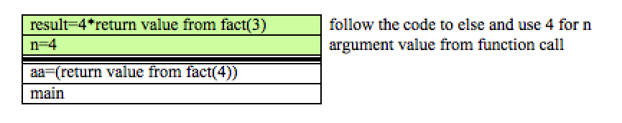

Since we make a function call to fact(3) we must now push that information onto the stack also. Note, return statement not reached before calling fact(3) so stack isn't popped at this point

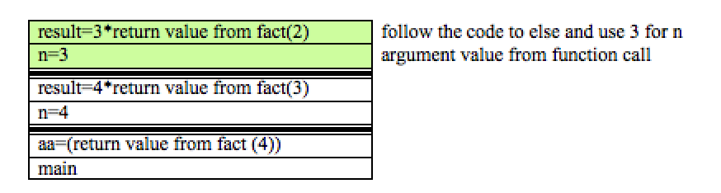

Again, because we are calling the function with fact(2) , we must also push this onto the stack 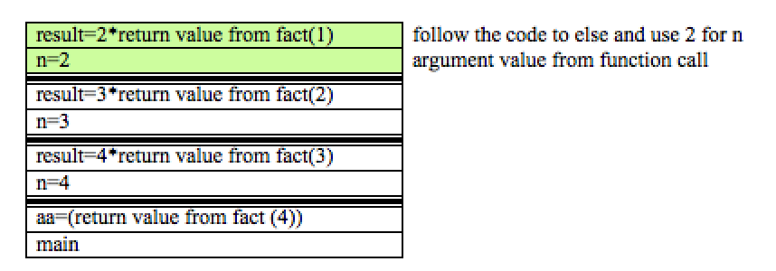

Once again, because we are calling the function with fact(1) we must also push this onto the stack 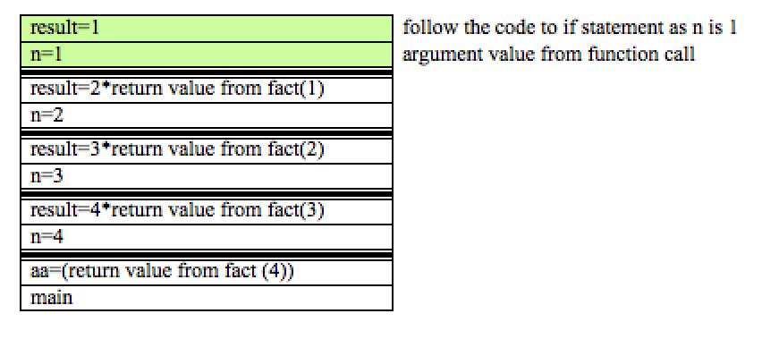

If we follow the code at this point we can see that we are able to reach the return statement without further function calls. Thus, we can now pop the stack.

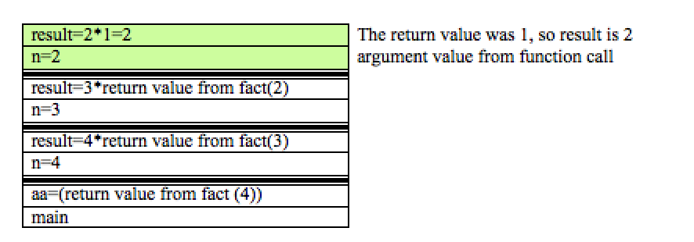

This will lead to the completion of the topmost function call and again, it can be removed from the stack. This time, the return value is used to solve the problem one more layer above:

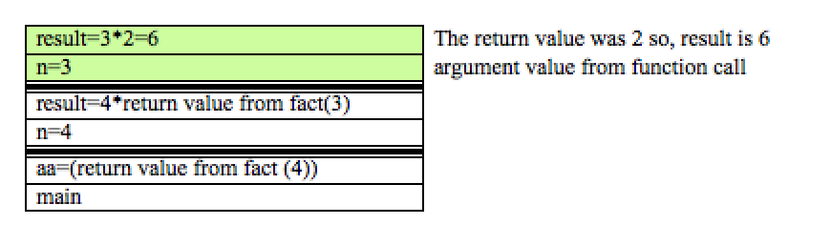

This will lead to the completion of the topmost function call and again, it can be removed from the stack. This time, the return value is used to solve the problem one more layer above:

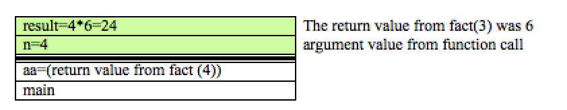

Finally, we can go back to main, as we have reached the final result:

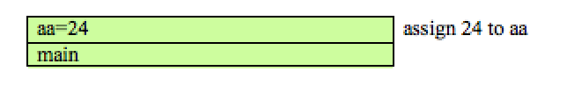

**Practice Problem:**

**1. Sum of digits**

* **Write Algorithm**

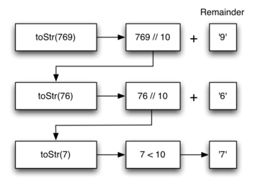

Initially S = “ “

N = Number

B = Base

**Display digits considering base = 10**

Convert((N)

1. if (N<10) print (N) return

2. Convert(N/10)

3. print (N%10)

4. Return

**Display digit considering base = 2 (N is a binary number)**

**N/base**

**N%base**

//**Sum of all digits**

Sum_digit = n%10 + sum_digit(n/10)

**Sample table for simulation or “dry run”**

|  |  |  |  |
| --- | --- | --- | --- |
| N | O/P | Stack | Line |
| 789 |  |  |  |
|  |  |  |  |
|  |  |  |  |
|  |  |  |  |
|  |  |  |  |

**2. Sum of first n elements using recusion :**

enter image description here

We can easily deduce that sum of array is equal to :

**First element + sum of the remaining elements of the array** i.e 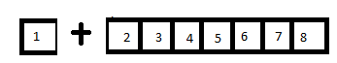

Here we get two parts: **first element+ an array of rest of elements**.now the second part itself is an array whose sum is again **its first element +sum of the remaining elements of the array**. and so on.

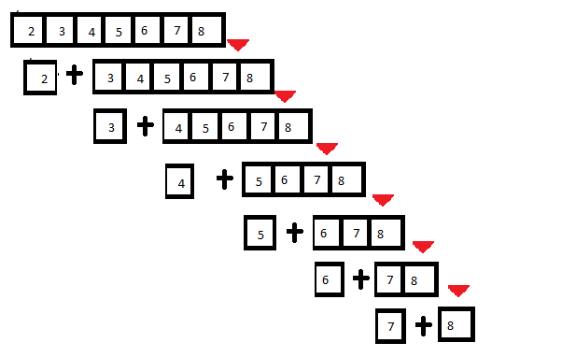

**//For Sum of n elements of an array**

Int S[10]

For(i=0;i<10;i++)

Sum+=s[i]

S= 1020

S +1 1024

S+2 1028

S+3 1032

Sum = *s + sum(s+1)

|  |  |  |
| --- | --- | --- |
| Sum of first n numbers  Sum(n)  {if n <= 1 return 0  S = n + sum(n-1) | Sum of any n elements in an array  Sum (s)  {if s[0] == -1  Retun 0  S = S[0] + sum(s++) | Input Empty array s[0] = -1 |

**All recursive algorithms must obey three important laws:**

1. A recursive algorithm must have a **base case**.
2. A recursive algorithm must change its state and move toward the base case.
3. A recursive algorithm must call itself, recursively.

**Issues:**

* Issue of Infinite loop if improper base condition may result in stack overflow
* Or with insufficient memory it may end up with stack overflow

**Convert Recursion into iteration :**

If we wanted to convert an algorithm from a recursive form to an iterative form, we could simulate this process with our own stacks.

*Any* recursive algorithm can be converted to an iterative form by using a stack to capture the “history” of

* actual parameters
* local variables

that would have been placed on the activation stack.

The general idea is:

* recursive calls get replaced by push
  + depending on details, may push new values, old values, or both
* returns from recursive calls get replaced by pop
* main calculation of recursive routine gets put inside a loop
  + at start of loop, set variables from stack top and pop the stack

### Example Iterative procedure for Factorial using User defined stack

push**(**s**,** top**,** ele**)**

1 if **(**top **>=** MAX**)** print “Stack Overflow"2 else s**[++**top**] =** ele**;** 3 return top**;**

pop**(**a**,** top**)**

1 if **(**top **>=** 0**) t**op **=** top **-** 1**;**  
 2 return a**[(\***top**) +** 1**];**3 else print "Stack underflow”  
 4 return 0**;**

main**()**

1 TOP = -1; // stack variables that mainntain stack's top  
2 Input n  
3 if(n<=0) print “The number can not be less than 0", return  
4 I = n  
5 repeat step 6 while i >0 , step -1 //Push all the elements in the stack  
6 TOP = push(s,TOP, i);  
 // now pop all the elements one by one  
 // multiply them with the answer variable  
7 Repeat step 8 while(TOP>=0)  
8. ans = ans * pop(s,TOP);  
 9. Print ,ans;

Self Study

Tower of Hanoi

<https://www.freecodecamp.org/news/analyzing-the-algorithm-to-solve-the-tower-of-hanoi-problem-686685f032e3/>

<https://www.tutorialspoint.com/data_structures_algorithms/tower_of_hanoi.htm#:~:text=Tower%20of%20Hanoi%20puzzle%20with%20n%20disks%20can%20be%20solved,3%20%2D%201%20%3D%207%20steps>.